CSS Advanced Selectors

* **Element selector**: for example -> **h1{}**, **li {}** etc.
* **Class selector**: for example -> **.container {}**, **my class {}** etc.
* **Id selector**: for example -> **#tom {},** **#speciallink {}** etc.
* **All selector**: for example -> **\*{}**. Everything inside will be applied to whole document.
* **Descendant selector:** for example, => **ul li a {}.** This will select all a tag inside the li tag which are inside an ul tag. Another example -> **li. hello {}.**
* **Adjacent selector:**  it will let us select an element that come after another element (not the nested elements -> like lists inside an ul, but the siblings). For example -> **h4 + ul {}.**  It will select all the ul elements after that h4 element.
* **Attribute selector:** for example -> **a [href=” www.google.com”], input[type=”text”], input [type=” checkbox”]** etc.
* **Nth of type:** for example -> **ul:nth-of-type(3) , ul:nth-of-type(even)** etc. It will select all the even number of ul from that list.
* Direct selectors usually have better performance than combinator selectors. Even though combinators works fine in itself. Usually, we work with the descended selector

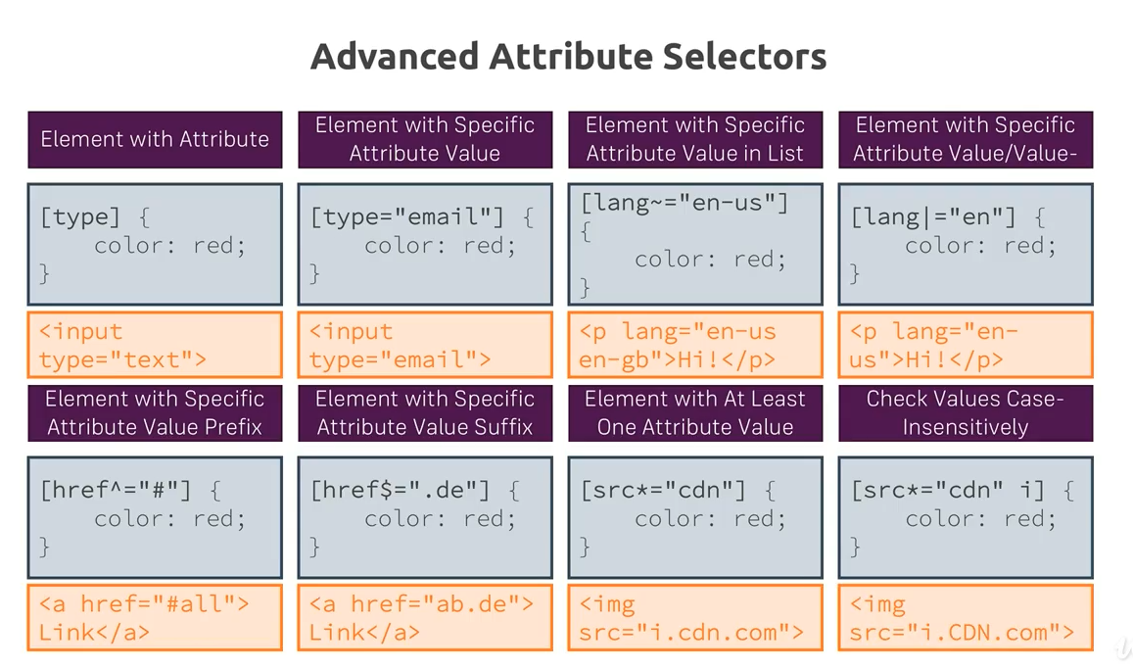

CSS Combinator Selectors

